Gasland
Hydraulic Fracturing in the Marcellus Shale

- Shade in the Marcellus shale rock formation in this map.
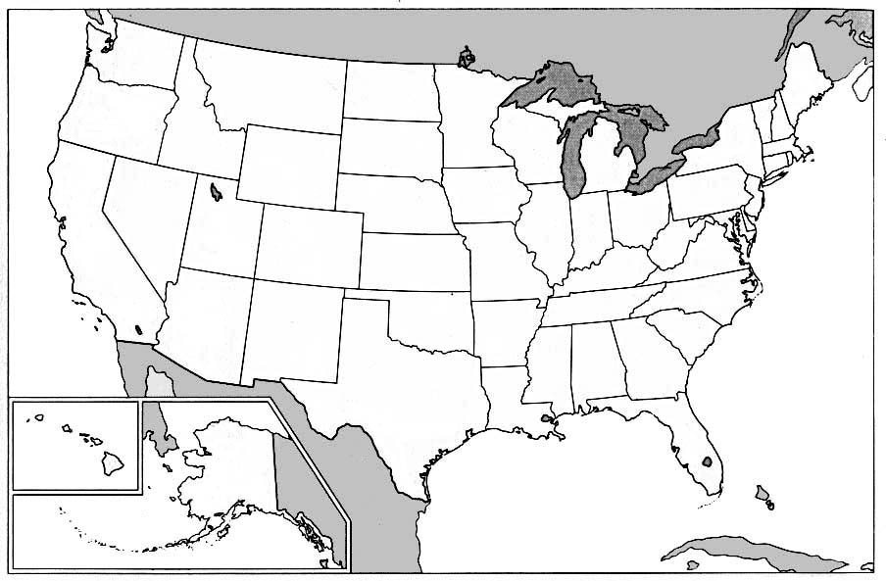
Image from vmapas.com

- How much was Josh Fox offered to lease his land for natural gas drilling?

- The Energy Policy Act provided exemptions for the oil and gas industries. What laws were they exempt from?

- When was the exemption passed, and who was president?

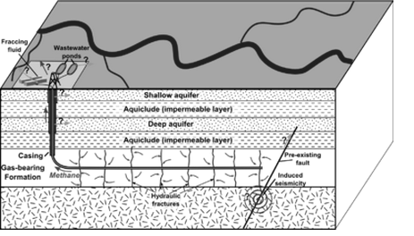
- Explain the process of hydraulic fracturing, as explained in the movie. Include fracking fluid and the amount of water used in the process.

Water, Water, Everywhere
Not a Drop To Drink

- What health effects were experienced by the residents of Dimock, the community drilled by Cabot Oil and Gas?

- What changes in water quality were observed?

- What was contained in the jar that Josh collected in Dimock?

Life in the Red Zone

- Why does the water light on fire? What is mixed with it that is combustible?

- Why is this area of Colorado referred to as the “Red Zone”?

- What is trichlorobenzene?

- What possible conflicts of interest existed with the Vice President for passing the exemptions to the Clean Water Act?

- Explain why the EPA is “not present” as defined by Weston Wilson.

Easter in Wyoming

- Why was the reverse osmosis system installed as a result of the lawsuit ineffective at filtering the water?

- What happened when Lewis Meeks’ new water well was drilled?

- What was the gas company legally required to do as a result?

- Describe the quality of the water that comes out of the Meeks’ original water well.

- What are the physical and chemical properties of glycol ethers?

- What effects does the natural gas drilling and fracturing have on the John Fenton’s cattle farms?

Your Land, My Land, Gas Land

- What is Bureau of Land Management (BLM) land, and what rights does the American public have to it?

- What is the purpose of the derrick?

- How many truckloads of hydraulic fracturing water must be brought in?

- How much of the water injected into the well is actually recovered?

- What is the purpose of the flowback pits?

- What is the purpose of the evaporation sprayers?

- What is the purpose of the separator?

- What is contained inside the condensate tanks?

- How do the gas wells affect the native animal populations, such as the pronghorn antelope?

Drop Everything, Clear Your Schedule

- Fracking chemicals are proprietary – explain what this means.

- List and describe the neurological effects of the VOCs and other air pollutants, as described by Dr. Theo Colborn.

Contamination at Divide Creek

- What effect did the seepage have on Divide Creek?

- Was the company responsible fined? How much?

The Air Over Fort Worth

- How do the air pollution emissions from the oil and gas drilling compare with the car exhaust from the entire Dallas-Ft. Worth area?

- What two categories of toxins were present in the air at Dish, Texas as a result of the gas pipelines that pass through the area?

It Doesn’t Take a Genius

- Explain what happened when the storm surges from the hurricanes reached the Gulf coast.

Throwing Water on a Drowning Man

- The results of the tests of the contaminated wastewater from Dimock produced several above-normal results. Explain what each of these measures:

  - Conductivity –

  - Total Kjeldahl Nitrogen –

  - Methylene Blue Active Substance (MBAS) –

- Explain how surfactants can affect fish.

Questions for Further Discussion

- John Hanger, Secretary of the Pennsylvania Department of Environmental Protection describes the natural gas drilling and extraction as a “trade-off”. Explain what the trade-off is. Do you believe this is a good trade? Natural gas is often described as a “transition fuel” and a cleaner-burning fossil fuel. Explain how these claims are incomplete. Given what you learned from this movie, is natural gas a fuel that we should explore and extract more of?

- The Fracturing Responsibility and Awareness of Chemicals (FRAC) Act proposes to include hydraulic fracturing as an activity regulated under the Safe Drinking Water Act. This law would require the industry to disclose all chemicals used in fracking. Do you think this law is fair and justified? Why might the gas drilling companies oppose this law? Explain your answer.

- This is a map of Pennsylvania, showing the major rivers and the towns of Dimock and Milanville. How would contamination of the water supply have consequences for the entire eastern part of the state, including Philadelphia?

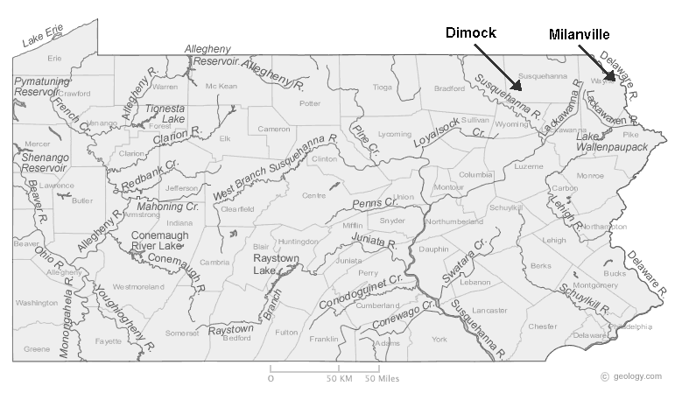

- The Colorado Oil and Gas Conservation Commission has released a statement explaining several inaccuracies it feels that the documentary portrays. The statement is available here:
http://cogcc.state.co.us/library/GASLAND%20DOC.pdf
Briefly describe their statement on the following:

The Weld County Wells:

The West Divide Creek Seeps:

- If you owned a large parcel of land in the shale area, and were offered several thousand dollars per acre to lease the land for gas drilling, would you take the money? Explain your decision.
-

